User Requirements for
Flight Deck

Approval
Approval of this document denotes that all signatories understand the related process, authors have conducted a review with interested parties; and approvers agree with the content of this document within their areas of accountability.
AUTHORSHIP
Name and Function | Signature | Date
Haja Thowfeek  Author | See approval page for signature | See approval page for date
APPROVAL
Name and Function | Signature | Date
John Doe  Business Owner | See approval page for signature | See approval page for date
First LastName  Tech Owner | See approval page for signature | See approval page for date
N/A  Governance, Risk & Compliance (GRC) | Not applicable as this system is not a GxP, SOX,  S/RPI and not a CSI/TIRE1 System | N/A
N/A  Quality Assurance (QA) | Not applicable as this system is not a GxP, SOX,  S/RPI and not a CSI/TIRE1 System | N/A

TABLE OF CONTENTS
1.0 Purpose 4
2.0 Supported Business Processes 4
2.1 Business Process Flow 4
2.2 Business Process Steps 4
2.3 Business Process Rules 4
2.4 Business Process Data Flow 5
2.5 Business Process Data Criticality 5
2.6 Business Process Data Retention 5
3.0 User requirement Standards 5
3.1 Nomenclature: Identification and the Numbering Scheme 5
4.0 Intended Use and User Stories 6
4.1 User Stories 6
5.0 User requirements 7
5.1 <Name of Use Case or User Story 1 of N> User Requirements 7
5.2 <Business Process Rules> User Requirements 7
5.3 <Performance & Business Continuity> User Requirements 7
5.4 <Security> User Requirements 7
5.5 <Regulatory> User Requirements 7
5.6 <Data Governance> User Requirements 8
5.7 <Interfaces> User Requirements 8
6.0 Glossary 9
6.1 Acronyms, Key Terms and Definitions 9
7.0 Appendices 9
8.0 References 9
9.0 DOCUMENT Revision History 9

Purpose
This User Requirements Specification (URS) document defines the business and user requirements for the Flight Deck digital solution.
The Flight Deck solution is designed to support clinical study monitoring and planning activities by providing users with capabilities to:
- Monitor portfolio-level study performance through KPI dashboards
- Analyze study-level enrollment and operational performance metrics
- Identify and compare similar clinical study protocols to support planning and decision-making

Supported Business Processes
The Flight Deck solution supports business processes related to clinical study monitoring, performance analysis, and study planning. The system enables end users to access, analyze, and act upon study data to support informed decision-making across study portfolios.
The primary business processes supported by this solution are:
.
Product Component / Functional Module | Supported / Automated Business Process(es) | Compliance Impact
Flight Deck – Portfolio Dashboard Module | Portfolio Performance Monitoring, Dashboard Filtering, Drill-Down Navigation | Non-GxP
Flight Deck – Study Overview Module | Study-Level Performance Analysis, Country and Site Comparison, Data Refresh and Monitoring | Non-GxP
Flight Deck – Protocol Similarity Search Module | Protocol Similarity Search, Results Ranking and Display, Protocol Detailed Review | Non-GxP

Business Process Flow
Please refer section 2.4 for Business Process flow diagram.

Business Process Steps
Detail or reference process steps. For each step a header statement with short description is sufficient.
BP Ref. | Business Process Step | GxP / SOX Impact
BP-01 | User accesses the Flight Deck system and navigates to the portfolio dashboard (UR-2) | Non-GxP
BP-02 | User views aggregated portfolio-level KPIs and performance metrics (UR-1, UR-3) | Non-GxP
BP-03 | User applies filters to refine dashboard data (UR-4, UR-5) | Non-GxP
BP-04 | User drills down from portfolio view to study-level details (UR-6, UR-7) | Non-GxP
BP-05 | System enforces role-based access to dashboard data (UR-8) | Non-GxP
BP-06 | System ensures acceptable dashboard performance (UR-9) | Non-GxP
BP-07 | User reviews study-level enrolment KPIs and trends (UR-10, UR-11, UR-12) | Non-GxP
BP-08 | User analyzes operational KPIs including milestones and study status (UR-13, UR-14, UR-15) | Non-GxP
BP-09 | User compares performance across countries and sites (UR-16, UR-17) | Non-GxP
BP-10 | User drills down to country-level and site-level insights (UR-18, UR-19) | Non-GxP
BP-11 | User refreshes data to view updated KPI information (UR-20) | Non-GxP
BP-12 | System enforces role-based access for study-level data (UR-21) | Non-GxP
BP-13 | User navigates to protocol similarity search (UR-22) | Non-GxP
BP-14 | User enters protocol details and initiates search (UR-22, UR-23) | Non-GxP
BP-15 | System displays top similar protocols with ranking and criteria (UR-24) | Non-GxP
BP-16 | User views detailed protocol information (UR-25) | Non-GxP
BP-17 | System applies similarity logic and returns results within performance threshold (UR-26, UR-27) | Non-GxP

Business Process Rules

BP Ref. | Business Process Rule | GxP / SOX Impact
BR-01 | The system shall restrict access to data based on user roles and permissions (RBAC) (UR-8, UR-21) | Non-GxP
BR-02 | The system shall ensure that dashboard and study-level data reflect applied filters accurately and dynamically (UR-4, UR-5) | Non-GxP
BR-03 | The system shall support navigation from portfolio-level to detailed study insights through drill-down capabilities (UR-6, UR-7, UR-18, UR-19) | Non-GxP
BR-04 | The system shall ensure accurate and consistent display of enrollment and operational performance data (UR-10 to UR-17) | Non-GxP
BR-05 | The system shall execute protocol similarity search based on defined criteria and return results within acceptable performance thresholds (UR-22 to UR-27) | Non-GxP

Business Process Data Flow
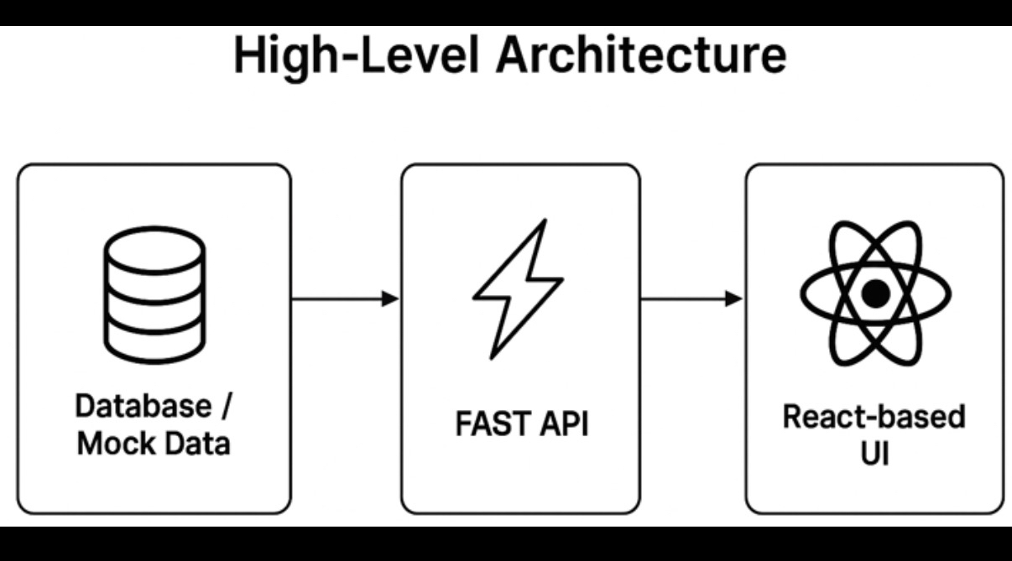

Business Process Data Criticality

BP Ref. | Data Type / Record | Criticality
BP-01 | Portfolio-level KPI data (study timelines, status, enrolment summaries) | None
BP-02 | Study-level enrolment and operational KPI data | None
BP-03 | Country and site-level performance data | None
BP-04 | Protocol search inputs (summary text, therapeutic area) | None
BP-05 | Protocol similarity results (scores, matching criteria, rankings) | None
BP-06 | Detailed protocol information (summary, sites, outcomes, lessons learned) | None

Business Process Data Retention

Data Type / Record | GRS Category | Description | Retention Period
Portfolio and study performance data | Not Applicable (Non-GxP) | Data used for monitoring and analytical purposes only | As per standard system data retention policy
Operational KPI and study-level data | Not Applicable (Non-GxP) | Data used for performance tracking and reporting | As per standard system data retention policy
Protocol data and similarity search results | Not Applicable (Non-GxP) | Data used for protocol comparison and planning | As per standard system data retention policy

User requirement Standards

Nomenclature: Identification and the Numbering Scheme

Range | Description
0100-0199 | System Functions (SF)
0200-0299 | Data Requirements (DA)
0300-0399 | Interface and Integration Requirements
0400-0499 | Feature Level Requirements
0500-0599 | Report and Form Requirements
0X00-0X99 | System Requirements
0X00-0X99 | Regulatory Requirements
0X00-0X99 | Software System Attributes
0X00-0X99 | Hardware Requirements
0X00-0X99 | Safety Requirements
0X00-0X99 | Communications Requirements

Intended Use and User Stories

User Stories

Study Portfolio Performance Dashboard
Description:
Provides users with the ability to view and monitor portfolio-level study performance through dashboards.
User Need:
Users need to analyze overall study performance to support monitoring and decision-making.

Study Overview – Enrollment & Operational KPIs
Description:
Provides users with access to detailed study-level enrollment and operational performance metrics.
User Need:
Users need to review and compare study performance to track progress and identify issues.

Protocol Similarity Search
Description:
Provides users the ability to search and view similar study protocols based on defined inputs.
User Need:
Users need to use historical protocol information to support study planning.

User requirements

User Requirements
UR ID | Requirement Statement
Story 1: Study Portfolio Performance Dashboard
UR-1 | The system shall allow users to view aggregated portfolio-level KPIs across studies. (AC-1)
UR-2 | The system shall display portfolio-level data upon dashboard load. (AC-2)
UR-3 | The system shall provide visual representation of portfolio performance metrics. (AC-3)
UR-4 | The system shall allow users to apply filters (phase, TA, region, status). (AC-4)
UR-5 | The system shall dynamically update dashboard results based on filters applied. (AC-5)
UR-6 | The system shall allow users to drill down from portfolio to study-level details. (AC-6)
UR-7 | The system shall display detailed study-level data upon drill-down. (AC-7)
UR-8 | The system shall restrict data visibility based on user role permissions (RBAC). (AC-8)
UR-9 | The system shall ensure acceptable performance for dashboard loading and interaction. (AC-9)
Story 2: Study Overview – Enrollment & Operational KPIs
UR-10 | The system shall display enrollment KPIs for selected studies. (AC-10)
UR-11 | The system shall show planned vs actual enrollment metrics. (AC-11)
UR-12 | The system shall provide enrollment progress trends. (AC-12)
UR-13 | The system shall display operational KPIs (milestones, status). (AC-13)
UR-14 | The system shall display site activation and milestone tracking. (AC-14)
UR-15 | The system shall display overall study status. (AC-1
UR-16 | The system shall allow comparison across countries. (AC-16)
UR-17 | The system shall allow comparison across sites. (AC-17)
UR-18 | The system shall support drill-down to country-level details. (AC-18)
UR-19 | The system shall support drill-down to site-level insights. (AC-19)
UR-20 | The system shall allow data refresh for updated KPI display. (AC-20)
UR-21 | The system shall enforce role-based access for study-level data. (AC-21)
Story 3: Protocol Similarity Search
UR-22 | The system shall provide protocol summary input (max 500 chars) and TA dropdown. (AC-22)
UR-23 | The system shall allow users to trigger similarity search. (AC-23)
UR-24 | The system shall display top 10 similar protocols with score and criteria. (AC-24)
UR-25 | The system shall provide detailed protocol view with metadata and outcomes. (AC-25)
UR-26 | The system shall apply similarity logic (text, TA, inclusion/exclusion). (AC-26)
UR-27 | The system shall return results within 3 seconds. (AC-27)

Business Process Rules - User Requirements
UR ID | Requirement Statement
UR-BR-01 | The system shall restrict access to portfolio, study, and protocol data based on assigned user roles and permissions.
UR-BR-02 | The system shall ensure that portfolio and study-level data displayed reflects user-applied filters accurately and dynamically.
UR-BR-03 | The system shall allow users to navigate from portfolio-level views to detailed study, country, and site-level information through drill-down functionality.
UR-BR-04 | The system shall present enrollment and operational performance data accurately to support study monitoring and analysis.
UR-BR-05 | The system shall support protocol similarity search based on defined criteria and return results within acceptable performance limits.

Performance & Business Continuity - User Requirements

UR ID | Requirement Statement
UR-PBC-01 | The system shall provide acceptable performance for users accessing portfolio dashboards, study-level views, and protocol similarity search functionality during normal operations.
UR-PBC-02 | In the event of a system outage, the system shall support recovery in line with agreed Recovery Time Objective (RTO) and Recovery Point Objective (RPO) as defined by standard enterprise IT business continuity and disaster recovery practices.

Security - User Requirements
UR ID | Requirement Statement
UR-SEC-01 | The system shall restrict access to portfolio, study, and protocol information based on assigned user roles and permissions.
UR-SEC-02 | The system shall ensure that users can access only the data and functionality appropriate to their role.
UR-SEC-03 | The system shall require users to authenticate before accessing the application.

Regulatory - User Requirements
UR ID | Requirement Statement
UR-REG-01 | The system shall support business operations without creating or managing regulatory records required for GxP, SOX, or other regulated submissions.
UR-REG-02 | Regulatory compliance requirements applicable to systems of record (e.g., clinical trial records, regulatory submissions) are not applicable to this system.

Data Governance - User Requirements
UR ID | Requirement Statement
UR-DG-01 | The system shall use study and protocol data for monitoring, analysis, and decision-support purposes only.
UR-DG-02 | The system shall ensure that data presented to users is sourced from authorized upstream systems.
UR-DG-03 | The system shall not be the system of record for clinical study or protocol data.
UR-DG-04 | Data ownership and stewardship shall remain with the respective source systems and business owners.

Interfaces - User Requirements
UR ID | Requirement Statement
UR-INT-01 | The system shall interface with authorized upstream systems to retrieve study, enrollment, and protocol data for analysis and display.
UR-INT-02 | The system shall present retrieved data to users through a web-based user interface.

Glossary

Acronyms, Key Terms and Definitions
Term / Acronym | Definition
URS | User Requirements Specification
KPI | Key Performance Indicator
RBAC | Role-Based Access Control
RTO | Recovery Time Objective – the targeted time to restore system availability after an outage
RPO | Recovery Point Objective – the maximum acceptable data loss measured in time
Non-GxP | System not subject to GxP regulatory requirements

Appendices

Appendix ID | Appendix Name or Title
N/A | No appendices are included for this User Requirements Specification

References

VQD ID | DTMS ID | Document Title
N/A | N/A | User Requirements Specification – Flight Deck
N/A | N/A | System Requirements Specification – Flight Deck

DOCUMENT Revision History
Version | Revision Details
1.0 | Initial version of User Requirements Specification for Flight Deck solution

